SMART BIO MONITORING SYSTEM

**SUBMITTED IN PARTIAL FULFILLMENT FOR THE REQUIREMENT OF THE AWARD OF DEGREE OF**

# BACHELOR OF TECHNOLOGY IN

**INFORMATION TECHNOLOGY**



**Submitted by GROUP – 40**

VINAY SINGH (1900290130190)

AMAN SAINI (1900290130023)

## SRIJAN JAISWAL (1900290130167)

TANUJ KUMAR (1900290130174)

**Supervised by**

**PROF. PRIYA SINGH**

# DEPARTMENT OF INFORMATION TECHNOLOGY KIET GROUP OF INSTITUTIONS, GHAZIABAD

**Session 2022-23**

# DECLARATION

We declare that

a. the work contained in this report is original and has been done by us under the guidance of our supervisor.

b. the work has not been submitted to any other institute for any degree or diploma.

c. we have followed the guidelines provided by the institute to prepare the report.

d. we have conformed to the norms and guidelines given in the ethical code of conduct of the institute.

e. wherever we have used materials (data, theoretical analysis, figures and text) from other sources, we have given due credit to them by citing them in the text of the report and giving their details in the references.

Signature of the student: 

Name: Tanuj Kumar

Roll number: 1900290130174

Signature of the student: 

Name: Aman Saini

Roll number: 1900290130023

Signature of the student: 

Name: Vinay Singh

Roll number: 1900290130190

Signature of the student: 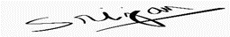

Name: Srijan Jaiswal

Roll number: 1900290130167

Place: KIET Group of Institutions, Ghaziabad

Date : 16th ,May,2023

# CERTIFICATE

This is to certify that the project Report entitled, “**Smart Bio Monitoring System**” submitted by **Aman Saini, Vinay Singh, Tanuj Kumar and Srijan Jaiswal** in the Department of Information Technology of KIET Group of Institutions, Ghaziabad, affiliated to Dr. A. P. J. Abdul Kalam Technical University, Lucknow, Uttar Pradesh, India, is a record of bonafide project work carried out by them/him/her under my supervision and guidance and is worthy of consideration for the award of the degree of Bachelor of Technology in Information Technology of the Institute.



**Signature of Supervisor:**

**Supervisor Name:** Prof. Priya Singh

**Date:** 16th May, 2023

**LIST OF FIGURES**

|  |  |  |
| --- | --- | --- |
| 1.1 | Arduino | 5 |
| 1.2 | Soil moisture | 6 |
| 1.3 | Temperature and humidity sensor | 7 |
| 1.4 | Ultrasonic sensor | 8 |
| 1.5 | Relay | 9 |
| 1.6 | Water Pump | 9 |
| 1.7 | Infrared sensor | 10 |
| 1.8 | Circuit Diagram of project | 12 |
| 1.9 | Displaying Result | 13 |
| 4.1 | Readings | 24 |

**ABSTRACT**

The Internet of Things (IoT) has revolutionized the way we interact with the physical world. By connecting everyday objects to the internet, IoT has enabled the collection of data and the provision of services that were previously not possible. This project takes advantage of IoT technology to develop a plant monitoring system that utilizes Node MCU and various sensors such as temperature, moisture, and humidity sensors to gather data on various aspects of the plant. The data collected will be used to provide valuable insights into the plant's health and optimize its growth and development. By monitoring the temperature, humidity, and moisture levels, the system will be able to detect and alert the user to any issues that may arise, such as over-watering or exposure to extreme temperatures. The project aims to improve the efficiency of plant cultivation and maintenance and provide a solution for monitoring the health of plants remotely. This will be especially useful for farmers, gardeners, and individuals who have plants in hard- to-reach or inaccessible locations. Additionally, the system will be able to provide data- driven insights into the best conditions for a particular type of plant, which will be useful for those who are new to gardening or are looking to optimize their cultivation efforts. The project is expected to make significant contributions to the field of IoT-based agriculture and improve the way plants are grown and maintained. It is designed to be scalable, so it can be adapted to various types of plants and environments, and it can also be integrated with other IoT-enabled devices to create a more comprehensive monitoring and control system. Overall, this project will offer an innovative solution for plant monitoring and maintenance, and it has the potential to improve the efficiency and sustainability of agriculture.

|  |  |
| --- | --- |
| **CONTENTS** |  |
|  | **Page No.** |
| Declaration | i |
| Certificate | ii |
| List of Figures | iii |
| Abstract | iv |
| **CHAPTER 1**: Introduction   * 1. Identification of Need   2. 1 Scope      1. Overview      2. Architecture         1. Arduino         2. Soil moisture Sensor         3. Temperature and Humidity Sensor         4. Ultra Sonic Sensor         5. Relay         6. Water Pump         7. Infrared Sensor      3. Technology Used         1. IOT Technology         2. Web Technology      4. Circuit Diagram      5. Project Images | 2  2  2  3  4  5  5  6  7  8  9  10  10  11  11  12  13 |
| **CHAPTER 2**: Literature Review | 14 |
| **CHAPTER 3**: Methodology  3.1 Proposed Methodology  3.2 Project Objectives | 23  23    23 |
| **CHAPTER 4**: Result  4.1 Result and Discussion | 24  24 |
| **CHAPTER 5**: Conclusion and Future Scope | 25 |
| |  | | --- | | 5.1 Conclusion | | 5.2 Future scope | | 25  25 |
| **CHAPTER 6:** References | 26 |
| **Appendix A** | 27 |
| **Appendix B** | 44 |

**CHAPTER 1**

**Introduction**

The aim of this project is to develop a system that automates and digitizes the field of agriculture, specifically targeting nursery farms. Agriculture is a crucial sector that plays a vital role in ensuring food security and supporting the economy. However, the adoption of automation in agriculture has been limited due to cost constraints. This project aims to address this issue by providing an affordable and efficient solution for monitoring and controlling climatic conditions that directly impact plant growth and production. The system utilizes IoT (Internet of Things) technology and automation to monitor and control various environmental factors, such as soil moisture levels, air temperature, and soil temperature. By employing sensors and a controller Arduino, the system collects real-time data on these parameters, providing valuable insights into the health and growth of plants. It can detect issues like over-watering or exposure to extreme temperatures and promptly alert the user to take necessary action.

Furthermore, the system incorporates water management features through alarms and automatic irrigation modules. Water is a precious resource, and the agricultural sector consumes a significant portion of it. However, inefficient irrigation systems and poor water management lead to substantial water loss. By implementing an alarm system and automatic water irrigation module, this project aims to reduce water wastage, contributing to improved water management practices. The system's scope extends beyond indoor potted plants, making it adaptable for outdoor gardens or larger areas through LAN (Local Area Network) or WAN (Wide Area Network) connectivity. This flexibility allows users to scale up their monitoring and control capabilities as needed.

The project's overarching goal is to increase agricultural efficiency and productivity by automating and digitizing the process, while also providing a cost-effective solution for monitoring and controlling the climatic conditions affecting plant growth and production. By empowering farmers and gardeners with real-time data, the system enables them to make informed decisions and optimize their agricultural practices. In the following sections, we will explore the architecture and components of the system, including Arduino controllers, soil moisture sensors, temperature and humidity sensors, ultrasonic sensors, relays, water pumps, and infrared sensors. We will also discuss the technology employed, such as IoT and web technologies, which enable seamless data collection, storage, analysis, and user interaction through web or mobile applications.

* 1. **Identification of Need**

The identification of need for this project is based on the need to monitor the effects of chemicals on living organisms, both for the protection of public health and the environment. Biomonitoring is the systematic measurement of compounds and detection of changes in cells or cell molecules in living organisms, in order to identify potential hazards and negative effects of chemicals [1]. This method has been found to be very valuable and has many advantages over other types of environmental monitoring. However, interpreting the data collected through biomonitoring can be difficult and requires careful analysis. Despite these challenges, the development and use of biomonitoring can lead to a better understanding of the effects of chemicals on living organisms and ultimately result in increased protection of public health and the environment.

* + 1. **Scope**

The scope of this project is to develop a system that will automate and digitalize the field of agriculture, particularly for nursery farms. In today's world, everything can be controlled and operated automatically, but there are still important sectors where automation has not been fully adopted, such as agriculture. One of the reasons for this is the cost. This system aims to address that issue by providing an affordable and efficient solution for monitoring and controlling the climatic conditions that affect plant growth and production. The system will use automation to control industrial machinery and processes, which will replace human operators. This will lead to more accurate and efficient monitoring and control of the climatic conditions that directly or indirectly govern the plant growth and hence their produce. Automation will help in increasing the productivity and efficiency of the agriculture sector [3]. The system will also aim to improve water management by using alarms and automatic irrigation modules. On average, farms around the world account for 70% of all water that is consumed annually. Of that 70% used by farmers, 40% is lost to the environment due to poor irrigation systems, evaporation, and overall poor water management. By using an alarm system or automatic water irrigation module, this project will help in decreasing this number, thus helping in water management. he system will use various plant sensors to monitor factors such as soil moisture levels, air temperature, and soil temperature. These sensors will provide valuable data that can be used to optimize the growth and production of the plants [2]. Although this system is suitable for indoor potted plants, it can also be extended for use in outdoor gardens or larger areas by using Local Area Network (LAN) or Wide Area Network (WAN). Overall, the main goal of this project is to increase the efficiency and productivity of agriculture by automating and digitalizing the process, and to provide an affordable and efficient solution for monitoring and controlling the climatic conditions that affect plant growth and production.

## **Overview**

The project aims to address the significant challenge of soil pollution in crop fields by developing a smart plant monitoring system that utilizes automation and IoT technology. Soil pollution is a pressing issue for farmers as it can adversely impact plant growth and health. To tackle this problem, the project focuses on creating a comprehensive monitoring system that continuously tracks crucial factors like soil moisture levels, air temperature, and soil temperature. The smart plant monitoring system is designed to detect and identify any potential issues that may arise, such as excessive watering or exposure to extreme temperatures. By monitoring these factors, the system can alert the user to take appropriate actions to mitigate the problem and ensure optimal plant growth and health.

The ultimate goal is to provide farmers with a tool that allows them to maintain the ideal conditions for their crops. Initially, the system is developed for monitoring indoor potted plants, providing an efficient solution for home gardening and indoor farming. However, it has the potential to be expanded to outdoor gardens or larger agricultural areas by utilizing Local Area Network (LAN) or Wide Area Network (WAN) connectivity. This scalability allows the system to be applied in various farming settings, catering to the needs of both small-scale and large-scale farmers. The project's main objective is to create an efficient and reliable monitoring system that utilizes automation and IoT technology. By doing so, the system aims to assist farmers in effectively maintaining the health of their crops and achieving sustainable growth. With continuous monitoring and real- time alerts, farmers can promptly respond to any issues and optimize their farming practices for improved crop yields and overall productivity.

## **Architecture**

This project focuses on creating a plant monitoring and smart gardening system using IoT with the help of a controller Arduino. The system will use various sensors such as a humidity sensor, moisture sensor, IR sensor, and temperature sensor to monitor and control the environmental conditions in a garden, such as temperature, humidity, moisture and IR sensor. The data collected by these sensors will be analyzed and used to provide valuable insights into the plant's health and optimize its growth and development. The system will be able to detect and alert the user to any issues that may arise, such as over-watering or exposure to extreme temperatures, and enable the user to take action [5]. The proposed system is designed for people who love gardening but are busy with their jobs or daily lives and can not maintain their garden regularly. The system helps to solve this problem by automating the watering of plants and monitoring other environmental factors such as humidity, soil and air temperature, pH, and light intensity. The system will upload this information to a cloud database, where it can be accessed and analyzed by the user to make informed decisions about their garden. The system will also automatically control the existing water system with the data collected from the garden sensors, this will help to conserve water by watering the plants only when necessary. Additionally, The system will also have the capability to monitor other environmental factors such as air quality, radiation levels and water pollution, this will help the user to take necessary action to maintain the healthy soil environment. This feature will also help the user to understand the real-time data on the environmental factors that are affecting the growth of their plants and make necessary adjustments. It will help users to easily monitor and maintain their garden, improve the efficiency of agriculture, and achieve sustainable growth by maintaining a healthy society. The system will also have the capability to send notifications to the user's mobile phone, reminding them to take necessary action or alerting them of any issues that may arise. This will ensure that the user is always aware of the status of their garden and can take necessary action in a timely manner [7]. Overall, this proposed system is an innovative solution that will greatly benefit gardeners and farmers by providing them with real-time data and control over their plants, helping them achieve optimal growth and productivity.

**1.1.3.1 Arduino**

Arduino is an open-source electronics platform that allows people to create interactive projects using a wide range of sensors, actuators, and other electronic components.as you can see the image of Arduino in figure 1 It is based on a microcontroller, which is a small computer that can be programmed to read inputs, process data and control outputs. Arduino boards come in various form factors, including the classic Arduino Uno, which is a small board with an ATmega328 microcontroller. They can be connected to a computer via USB to upload code, and can also be powered by batteries or other external power sources. Arduino boards can be programmed using the Arduino IDE, a software that allows users to write, upload and debug code on the board. The programming language is based on C/C++ and it is easy to learn [8]. Arduino boards are widely used in various projects such as home automation, robotics, IoT, data logging and more. It is also used in education and research as a tool for learning about electronics, programming, and engineering. With its simplicity, affordability, and versatility, Arduino makes it an ideal choice for beginners and professionals alike.

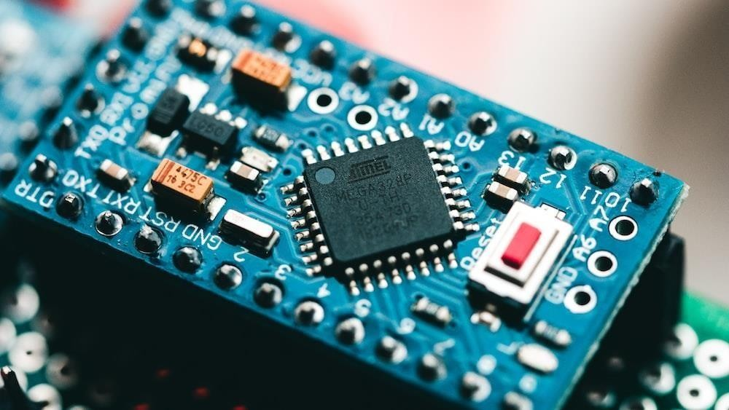

Figure 1.1 Arduino

**1.1.3.2 Soil moisture sensor**

A soil moisture sensor is a device that measures the amount of water present in the soil. It works by measuring the electrical resistance or capacitance of the soil, which changes as the soil becomes wetter or drier. As you can see the image of soil moisture sensor in figure 2. The sensor typically consists of two electrodes that are inserted into the soil, and a circuit that measures the resistance or capacitance between the electrodes. The sensor will detect the moisture of the soil and inform the user through a mobile application, alerting them to take necessary action. It also automatically controls the existing water system with the data collected from the garden sensors, helping to conserve water by watering the plants only when necessary. Soil moisture sensors are commonly used in agriculture, horticulture, and landscaping to optimize irrigation and fertilization, and to improve crop yields [2]. They are also used in the management of turf, golf courses, and other grassed areas to ensure optimal water use and to prevent waterlogging. The sensor can also be used to monitor soil moisture content in conjunction with other environmental factors such as temperature and humidity, to provide a more complete picture of the soil environment and to help in making better decisions about irrigation, fertilization, and other aspects of plant care [10].

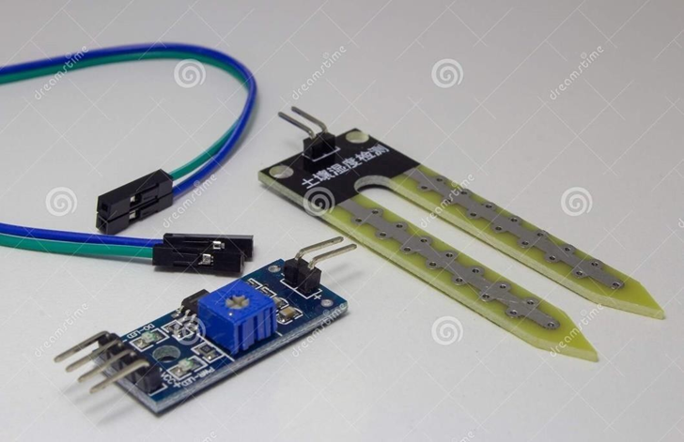

Figure 1.2. Soil moisture

**1.1.3.3 Temperature and Humidity Sensor**

A temperature and humidity sensor is a device that measures both temperature and humidity in the surrounding environment. These sensors typically consist of two main components: a temperature sensor and a humidity sensor. As you can see the image of Temperature and Humidity sensor in figure 3. The temperature sensor measures the ambient temperature, usually with a thermistor or thermocouple, which changes resistance or voltage as the temperature changes. The humidity sensor measures the amount of water vapor in the air, usually with a capacitive or resistive sensor [9]. Temperature and humidity sensors are commonly used in various applications such as HVAC, weather monitoring, agriculture, and indoor air quality monitoring. They can be used to control the temperature and humidity in buildings, greenhouses, and other enclosed spaces, to ensure optimal comfort and to prevent damage to materials or equipment. They are also used in weather monitoring to measure and track temperature and humidity trends, which can provide valuable information for forecasting and climate research. In agriculture, temperature and humidity sensors are used to monitor the environment in greenhouses or other controlled growing environments, to ensure optimal growing conditions and to improve crop yields [1].

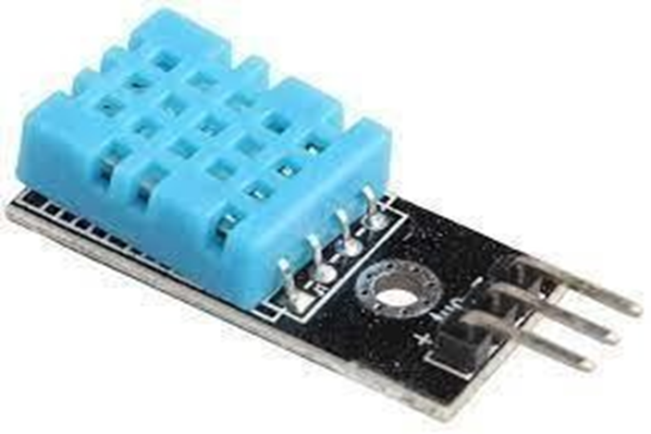

Figure 1.3. Temperature and Humidity Sensor

**1.1.3.4 Ultrasonic sensor**

An ultrasonic sensor is a sensor that uses sound waves at frequencies above the range of human hearing (ultrasound) to measure distance, speed, or other properties of objects. These sensors work by emitting a high-frequency sound wave, and then measuring the time it takes for the sound wave to bounce back (the time of flight) to calculate the distance to the object. Ultrasonic sensors are commonly used in a variety of applications such as robotics, industrial automation, security systems, and transportation. As you can see the image of Ultra sonic sensor in figure 4. Ultrasonic sensors can be classified as either transmitters or receivers. Transmitters emit the ultrasonic sound waves and receivers detect the reflected waves. Some ultrasonic sensors also include a built-in temperature sensor to measure ambient temperature, which can be useful for applications where temperature compensation is needed. These sensors are available in different configurations, some can be used for measuring distance, some for level measurement and flow measurement. They are commonly used in navigation systems for robots and drones, as well as in obstacle avoidance systems for cars and other vehicles [8]. Ultrasonic sensors are also used in 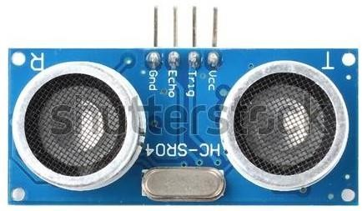applications such as parking assistance, industrial automation, and security systems.

Figure 1.4. Ultra Sonic Sensor

**1.1.3.5 Relay**

A relay is an electrically operated switch that can be used to control an electrical circuit. It is essentially a switch that is controlled by an electromagnet, rather than by a person flipping a switch or pressing a button. Relays are commonly used in a wide range of applications, including industrial automation, control systems, and telecommunications. Relays can be used to control a variety of loads, including lights, motors, and other electrical devices. They can also be used to isolate one part of an electrical circuit from another, providing a level of safety and protection for the circuit and its components. Relays can be controlled by a variety of inputs, including mechanical switches, electronic signals, and even computer programs. As you can see the image of Relay in figure 5. They are available in a wide range of sizes and configurations, and can be used in both DC and AC circuits. Relays are widely used in many industrial applications, in automobiles, home appliances, and many more [2]. They are also used in safety systems, such as fire alarms, security systems, and emergency shut-off systems, to protect people and property. Relays can be used to control large electrical loads and power-intensive devices, such as electric motors and lighting systems. They are also used in many industrial and commercial applications, such as controlling process equipment, automating production lines, and managing energy consumption.

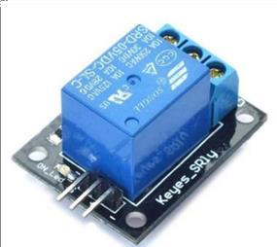

Figure 1.5 Relay

**1.1.3.6 Water Pump**

A water pump is a device that is used to move water from one location to another. It is a mechanical device that uses an impeller to force water through a pipe or other conduit. Water pumps can be powered by electricity, gasoline, diesel, or other means. They are commonly used in a variety of applications, including irrigation, water supply, and drainage. we have implemented an automated irrigation system that uses a water pump and a relay to control the watering of plants. The system is designed to provide the plants with the right amount of water at the right time, without wasting water or energy. This system is particularly useful for people who love gardening but are busy in their jobs or day-to-day lives and cannot maintain the garden regularly [9]. This system helps to save water and energy, as the water pump is only running when it is needed. It also helps to improve the growth of the plants by providing water at the right time and right quantity. Additionally, the use of a relay provides an added layer of safety and protection to the system, as it can be used to shut off the water pump in case of any emergency or malfunction.

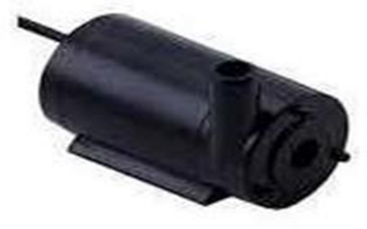

Figure 1.6 Water Pump

**1.1.3.7 Infrared Sensor**

An infrared sensor is a device that detects infrared radiation, which is electromagnetic radiation with a wavelength longer than that of visible light but shorter than that of microwaves. Infrared sensors are used in a wide variety of applications, such as remote controls, motion detectors, and temperature measurement. As you can see the image of Infrared sensor in figure 7. In remote controls, infrared sensors are used to detect the infrared signals emitted by the remote control and convert them into electrical signals that can be used to control the device. In motion detectors, infrared sensors are used to detect the presence of a person or object by sensing the infrared radiation emitted by the person or object. In temperature measurement, infrared sensors are used to detect the temperature of an object by sensing the infrared radiation emitted by the object. Infrared sensors are based on different technologies such as thermopile, pyroelectric, or bolometer [6]. They can be designed as a standalone device or as a component of a larger system. They are widely used in various applications like industrial, automotive, home appliances, and security systems. Some infrared sensors are designed to detect a specific wavelength range of IR radiation, while others are more general-purpose.

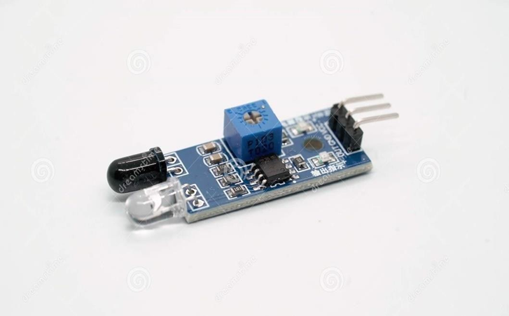

Figure 1.7 Infrared sensor

**1.1.4 Technology Used**

IoT technology is used to collect and transmit data from various bio monitoring devices, such as sensors and wearables, to a central hub or cloud platform. This allows for real-time monitoring and remote access to the data, as well as scalability for future expansion. By using IoT technology, we are able to gather accurate and comprehensive data from the bio monitoring devices, which is crucial for the functioning of our system. Web technology is used to create a user interface for the system. A web application or mobile app is developed that allows users to view and interact with the collected data. We have used technologies such as HTML, CSS, JavaScript, and any frameworks or libraries to build the web interface [1]. The use of web technology has provided us with the benefits of accessibility and ease of use for the system, as it can be accessed from any device with internet access. By combining IoT and web technology, we were able to develop a smart bio monitoring system that is efficient, accurate and easy to use. The data collected by the system is stored and analyzed in real-time, allowing for quick and effective monitoring of the bio parameters.

**1.1.4.1 IOT Technology**

IoT (Internet of Things) technology refers to the interconnectedness of everyday physical devices, vehicles, buildings and other objects embedded with electronics, software, sensors and connectivity which enables these objects to connect and exchange data with each other and with the external environment. It enables the communication between devices and applications over the internet, making it possible for devices to share data and for applications to control them remotely. IoT technology allows for the collection and analysis of large amounts of data from various sources, such as sensors and devices, which can be used to improve decision-making and automate processes. This can result in increased efficiency, cost savings, and improved safety. For example, in agriculture, IoT-enabled sensors can be used to monitor crop growth, soil conditions and weather patterns in real-time, which can be used to optimize crop yields and reduce the use of resources such as water and fertilizer. IoT technology is also used in a variety of other sectors such as smart homes, cities, transportation, healthcare, and manufacturing [2]. This technology helps to make our lives more convenient, efficient.

and secure. IoT technology is being used to develop smart cities, where various devices and sensors are used to monitor and control traffic, lighting, parking, and public safety. IoT technology is expected to continue to grow in the future, with an increasing number of devices and appliances becoming connected to the internet. However, the rapid growth in the number of connected devices also poses challenges for security, privacy and data management [10].

**1.1.4.2 Web Technology**

Web technology refers to the various tools, languages, and frameworks usedto create and maintain websites and web applications. Some common web technologies include HTML, CSS, JavaScript, and PHP. HTML (Hypertext Markup Language) is used to create the structure of a website, CSS (Cascading Style Sheets) is used to control the visual layout and design of a website, JavaScript is used to add interactive elements and dynamic functionality to a website, and PHP (Hypertext Preprocessor) is a server- side programming language that can be used to create dynamic web pages.

Web services are also a key component of web technology. Web servicesare a way for different applications to communicate and share data over the internet [2]. This allows for the integration of different systems, making it possible for a website or web application to access information from other sources. For example, a website can use a web service to access data from a database or retrieve information from a third-party API (Application Programming Interface). Additionally, web technology also includes web browsers, web servers, and web application platforms. Web browsers are the software that allows users to access and view websites. Web servers are the computers that host websites and make them available to users over the internet. Web application platforms are the software frameworks that are used to build and deploy web applications. These platforms provide a set of tools and services that make it easier to develop, test, and deploy web applications. Some examples of web application platforms include Ruby on Rails, Django, and ASP.NET[3].

**1.1.5 Circuit Diagram**

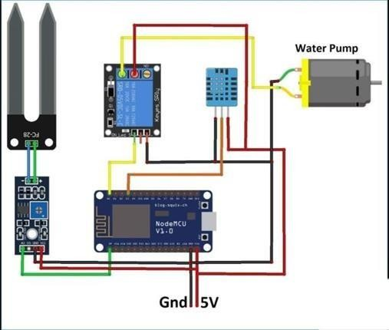

Figure 1.8. Circuit Diagram of Project

**1.1.6 Project Images**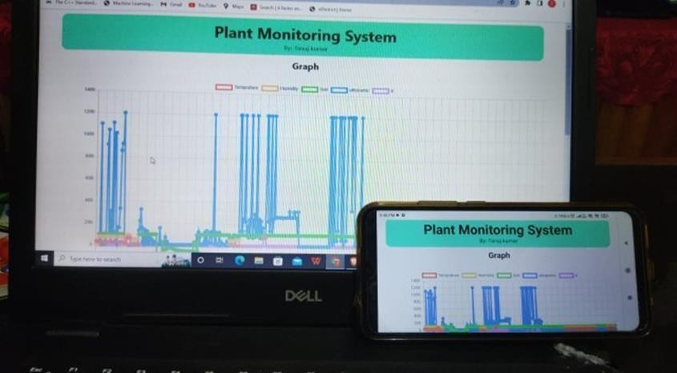

Figure 1.9. Displaying Result

**CHAPTER 2**

**2.1 Literature Review**

The combination of global climate change and population growth is putting increasing pressure on agricultural yields. To address this problem, crop performance monitoring is becoming increasingly necessary. One way to achieve this is through the use of sensors and biosensors that can detect changes in plant fitness and predict the evolution of their morphology and physiology. These sensors can be integrated into wearable and on-plant portable devices that provide continuous and accurate long-term sensing of morphological, physiological, biochemical, and environmental parameters. Flexible sensors and nanomaterials are inspiring the emergence of new fields in wearable and on-plant portable devices. These devices can provide continuous and accurate long-term sensing of morphological, physiological, biochemical, and environmental parameters. This technology can be used to monitor plant growth, detect disease, and optimize crop yields. The state-of-the-art sensing solutions for each application scenario are grouped according to the plant organ on which they have been installed. This allows for a better understanding of the technological advantages and features of each solution. The use of these technologies in agriculture has the potential to provide more accurate measurements for farmers and plant scientists. By tracking crop performance in real-time, farmers and scientists can optimize plant development through tailored treatments that improve overall plant health, even under stressful conditions. This ultimately leads to increased crop productivity in a more sustainable manner. However, there are also some challenges and limitations to the implementation of these technologies. For example, the cost of these devices can be high and the data they collect may require significant processing and analysis before it can be used effectively. Additionally, the devices may be affected by environmental factors such as temperature and humidity, which could lead to inaccuracies in the data collected. Despite these challenges, the application of these technologies in agriculture holds great promise for increasing crop yields and improving sustainability. As technology continues to advance, it is likely that more affordable and accurate sensors and biosensors will become available, making it easier for farmers and scientists to monitor crop performance and optimize yields.

1. Anaerobic digesters of Tehran waste water treatment plant (WWTP) working in mono- digestion operation are investigated for not only methane augmentation but also for waste minimization by the use of co-digestion process. Three types of co-substrate wastes including slaughterhouse flotation greases, biowaste, and cattle manure were selected because they were available in large amounts. A model was required to predict the volume flow rates of feeding co-substrate wastes into digesters during operation time for providing sufficient biogas in order to generate maximum gas engine power output. Thus, Anaerobic Digestion Model Number 1 (ADM1) for mono-substrate is modified so that it could be used with characterization of primary sludge, secondary sludge, and several co-substrate waste inputs into digesters. Then, appropriate coefficients (hydrolysis coefficient and bio-degradability factor) in this model were determined by the use of sludge biochemical methane potential (BMP) tests. After complete modification, calibration and validation of ADM1 method with experimental values of primary and secondary sludge for anaerobic digestion (which is the current reality in Tehran WWTP), the developed model is integrated with a co-substrate feeding strategy for estimation of required feed flow rates of co-substrate wastes. Results indicated that feeding grease, biowaste and manure increased the average generated biogas from 10524 m3/day (62.1% CH4) to 29161 m3/day (61.5% CH4), 30183 m3/day (59.5% CH4), and 32531 m3/day (53.8% CH4), respectively. Also, the gas engine power output increased from an average value of 906 kW to about 2.5 MW (during the studied operation time period). Low hydrolysis coefficient and low degradability of manure caused high bio- degradable feed flow rate of this co-substrate waste to about 58,200 kgCODb/day in average. This value for biowaste and grease was 38,800 and 36,100 kgCODb/day, respectively. Feeding grease and biowaste into digesters increased COD removal efficiency from 37% to 58% and 54%, respectively, while feeding manure dropped it to 31%. Furthermore, values of pH and VFA/Alk indicators showed stable conditions in digesters. Moreover, it was found that all three co- digestion processes did not impose a new load on other WWTP equipment for reducing nitrogen in the effluent stream of WWTP. Finally, it was concluded that biowaste is an appropriate co-substrate for our case study.

2. The identification and quantification of plant pathogens in the early stages of infection play an important role to ensure food security and decrease crop loss. Over the past years, advances in nanomaterials research have allowed the development of novel plant disease (bio)sensors with high sensitivity and specificity. In this review, we address the use of different 0D, 1D, 2D and 3D nanomaterials for designing varied plant disease (bio)sensors. Specifically, the appealing features of nanomaterials, including high surface area/volume ratio, tunable physical- chemical properties and capability to incorporate biomolecules, are discussed, while illustrative examples on how they can be applied to improve the performance of electrical, electrochemical, optical, gravimetric and thermal sensors are presented. Finally, future trends, challenges and opportunities on the use of such nanomaterial-based (bio)sensors for on-site and expedite plant pathogen detection are also presented.

3. The chapter provides an in-depth exploration of the potential applications of carbon dots (CDs) in the agricultural domain. CDs possess a range of advantageous attributes that make them highly suitable for use in agriculture. Their low toxicity ensures minimal harm to the environment and living organisms, including plants. Additionally, CDs exhibit biocompatibility, meaning they are well-tolerated by biological systems. One of the key advantages of CDs is their facile synthetic strategies, allowing for easy and scalable production. This scalability is crucial for practical implementation in agricultural settings where large quantities of CDs may be required. Moreover, CDs demonstrate good solubility and stability during usage, ensuring their effectiveness and longevity in agricultural applications. Another notable characteristic of CDs is their easy tunability of surface functionality. This attribute allows researchers and scientists to modify the surface properties of CDs to suit specific agricultural applications. By tailoring the surface functionality, CDs can be designed to interact with plants in a targeted manner, enhancing their efficacy and performance. The chapter begins by providing an overview of the preparative approaches used to synthesize CDs. It also discusses the structural characteristics and important physicochemical properties of CDs. This foundational knowledge is crucial for understanding their subsequent interactions with plants. The focus then shifts towards exploring the uptake, translocation, and accumulation of CDs in plants. The goal is to understand the intricate bio-nano crosstalk that occurs between CDs and various plant species. This crosstalk encompasses the effects of CDs on plant growth, development, and physiological processes. The chapter examines how CDs influence important aspects such as photosynthetic efficacy, nutrient assimilation, and the plant's ability to withstand biotic and abiotic stresses. Additionally, the chapter highlights recent endeavors in using CDs for bio-freight conveyance into plant systems. This involves utilizing CDs as vehicles for delivering various bioactive compounds, such as nutrients, pesticides, or growth regulators, directly to plants. This targeted approach holds great potential for enhancing agricultural practices by ensuring efficient and precise delivery of beneficial substances to plants. Overall, gaining a better understanding of the bio-nano crosstalk between CDs and plants can significantly contribute to sustainable agriculture. By harnessing the unique properties of CDs and exploring their interactions with plants, researchers can develop innovative solutions for improving crop yield, plant health, and overall agricultural sustainability.

4. Selective breeding is a process that has been used by farmers for centuries to develop different varieties of plants and animals. This process involves selecting the individuals with the desired traits and breeding them together to produce offspring with those traits. Over time, this process can lead to the development of new varieties that are well-suited to specific environments or have specific characteristics, such as increased yield or resistance to disease. New methods in genetic engineering (GE) can facilitate this same process by improving the speed and specificity with which genes and associated traits can be altered. Genetic engineering techniques such as CRISPR-Cas9 allow scientists to make precise changes to the genome of an organism, which can be used to introduce new traits or modify existing ones. This can be a faster and more efficient way to develop new varieties of plants and animals than traditional breeding methods. While traditional methods of transgenesis, which involves the transfer of genes from one organism to another, can be error-prone and unpredictable, targeted genome editing protocols are becoming increasingly more precise and safe. This is because these newer methods can make specific changes to the genome at a certain location, rather than introducing new genes from another organism. This increases the predictability and control of the final outcome, and reduces the risk of unintended consequences.

5. Plant diversity is essential to maintain terrestrial ecosystem stability and balance, but it is highly susceptible to environmental changes that are generally dominated by human activities. In the natural habitat, plant growth and distribution patterns are known to be regulated by abiotic environments such as water, temperature, and nutrient. However, how growing human dominance impacts plant diversity at the watershed scale remains unclear. From the view of the meta-watershed ecosystem, this study constructed indicators to examine the plant diversity responses in karst watersheds of different urban development intensities. The results revealed that the growing urban development intensity deteriorated plant diversity and riparian plant diversity in the meta-watershed ecosystem. Both socioeconomic and water conservancy development had noticeable adverse effects on plant diversity. The riparian plants were more susceptible to artificial development than forest plants. The predicted results of various development scenarios suggest that, by the middle of the 21st century, plant diversity and food production in the watershed will meet a crisis unless forest protection policies are applied, and large-scale urban expansion is curbed. In the meta-watershed ecosystem, growing human dominance increasingly destroys plant diversity and the ecosystem supply. Policies and measures are urgently needed to reverse the potential deteriorating trend of the ecosystem, maintain the stability of the ecosystem, and promote the sustainable development of human society.

6. Cupolas are among the most important historical remains from the Seljuk Empire period in the Erzurum city center. Unfortunately, many vascular plants have been colonized on these cupolas. As is known, the colonization of vascular plants on historical structures causes severe damage. There search of vascular plants growing on the surface of historic buildings is necessary for the assessment of the risk of biodegradation of stones and maintenance planning. This study aimed to determine the deteriogenic vascular plants on the Three Cupolas and Double Minaret Madrasah Cupola, which are among Erzurum's most significant historical heritages, and also to investigate the effects of these plants on the deterioration of the stone structure of the cupolas. The species present on the wall and in the perimeter of each cupola were sampled and 47 plant species belonging to 19 families were identified. Plants were analyzed for diversity, structure, origin, and damage to historical structures, and the hazard index was applied to evaluate the impact of deteriogens. It was found that Acer negundo, Scrophularia libanotica, Artemisia armeniaca, Medicago sativa, and Melilotus officinalis were the most damaging plants to the cupolas. Various methods to wipe out deteriogenic vascularplants on the cupolas were discussed and suggestions were made. The results highlighted that building material and plant life form influence degradation in the cupolas and the importance of management strategies to eradicate

7. Stem cells possess the remarkable ability to self-renew and differentiate into specialized cell types. Although there are differences in the origin, form, and destinations of stem cells between animals and plants, they are governed by similar epigenetic mechanisms during the process of differentiation. In recent years, there has been growing evidence indicating that the three- dimensional (3D) organization of the genome, known as the chromatin conformation, plays a crucial role in regulating gene expression during stem cell differentiation. While studies focusing on chromatin interactions and gene expression regulation in animal systems have been extensively explored, research in plant cells in this area is still in its nascent stages, making it an emerging and promising field for future investigations. This review aims to provide a comprehensive summary of the similarities between plant and animal stem cell niches and their respective roles in maintaining stem cell populations. Both plant and animal stem cell niches involve specialized microenvironments that provide signals and factors necessary for stem cell self-renewal and differentiation. Understanding these niches and the mechanisms underlying stem cell maintenance is essential for unraveling the complex processes of growth and development in both plant and animal organisms. Furthermore, the review focuses on the significance of changes in chromatin conformation in regulating gene expression during stem cell differentiation. In animal systems, extensive research has demonstrated the importance of chromatin organization in controlling gene activity and cell fate determination. However, investigations specifically targeting chromatin organization and its impact on gene expression in plant cells are still in their early stages. This emerging area of research holds immense potential and is expected to shed light on the regulatory mechanisms governing gene expression and cell fate determination in plants. The review also highlights recent findings concerning chromatin organization in plant cells at both genome-wide and loci-specific levels. Genome-wide studies provide a global perspective on chromatin interactions and their influence on gene expression patterns, while loci-specific investigations offer detailed insights into the specific regions of the genome that undergo conformational changes during stem cell differentiation. By synthesizing existing knowledge and highlighting recent advancements, this review underscores the importance of chromatin conformation in regulating gene expression during stem cell differentiation in both plants and animals. Moreover, it emphasizes the need for further research in plant systems to fully elucidate the role of chromatin organization in plant development and to unravel the unique aspects of gene regulation in the context of plant stem cells. Future studies in this field have the potential to deepen our understanding of plant biology and provide valuable insights into the fundamental processes of stem cell maintenance and differentiation in plants.

8. A team consisting of Latifah, W. Ramdhani, and M.R. Nasrulloh developed an IoT-based system specifically designed to monitor the growth of corn. The system operates through a series of steps, with each component playing a crucial role. It utilizes an ultrasonic sensor as the input device to detect the height of the corn plants. The data collected by the sensor is then transmitted to a Raspberry Pi, which serves as the controller for the system. Once the data is received by the Raspberry Pi, it is processed and stored for further analysis. The system is designed to enable data visualization and monitoring, allowing users to view the corn plant's growth progress on their personal computers. This is achieved through an intranet connection, which facilitates data transfer between the Raspberry Pi and any device within the same IP address range. The researchers conducted prototyping experiments to validate the system's functionality. Initially, the system was designed to monitor the growth of a single corn crop. However, the team emphasizes that the system can be scaled up for application in a larger cornfield. The use of a Raspberry Pi as the control unit provides the necessary specifications and capabilities to handle such scalability. Unlike alternative control units such as Arduino or microcontrollers, the Raspberry Pi offers faster data processing and easy access to complementary devices via the internet or a local area network (LAN). Overall, this research presents an IoT-based system tailored for monitoring corn growth. By leveraging the capabilities of the ultrasonic sensor, Raspberry Pi, and intranet connection, the system allows for efficient data collection, processing, and visualization. The scalability of the system holds potential for utilization in larger cornfields, thanks to the Raspberry Pi's robust control capabilities and the flexibility of intranet connections.

9. The study conducted by J.S. Dvorak, M.L. Stone, and K.P. Self examined the use of ultrasonic sensors for detecting objects and animals commonly found in agricultural fields. Ultrasonic sensors are commonly used in various industries, including agriculture and construction, for object detection and proximity sensing. The researchers aimed to determine the effectiveness of these sensors in detecting different types of objects and animals encountered in outdoor environments. The study revealed several important findings. Firstly, it found that ultrasonic sensors were proficient in detecting rigid objects that were larger in size compared to other objects. This means that objects like metal equipment or solid structures could be reliably detected using ultrasonic sensors. However, the sensors struggled to detect objects with extremely soft surfaces and textures. This limitation means that objects like small or delicate items, or animals with soft skin, may not be accurately detected by ultrasonic sensors. Furthermore, the study found that medium-sized objects were occasionally not detected within a range of 0.01m to 3m. This implies that there is a range limitation for ultrasonic sensors, and objects within this range may not always be detected reliably. It is important to consider this limitation when designing systems for outdoor environments, such as agricultural or construction fields, where medium-sized objects may be present. These findings have significant implications for the design of future systems intended for outdoor environments, particularly in the agricultural and construction fields. Designers should be aware that ultrasonic sensors may not be suitable for detecting certain types of objects or animals commonly encountered in these environments. Small or soft-skinned animals, as well as delicate objects, may not be reliably detected using ultrasonic sensors alone. The study highlights the importance of testing ultrasonic sensor capabilities in the specific environments in which they will be used. By conducting tests in real-world conditions, designers can gain insights into the performance limitations of ultrasonic sensors and make informed decisions about sensor selection and system design. This will ultimately help optimize future systems for the specific objects and conditions that they will encounter in the field, improving their reliability and effectiveness. In summary, the study indicates that while ultrasonic sensors are effective in detecting larger, rigid objects, they may struggle to detect objects with soft surfaces or textures. Additionally, there is a range limitation for medium-sized objects. Designers of systems for outdoor environments should consider these limitations and conduct thorough testing to ensure the sensors are optimized for the specific objects and conditions they will encounter.

10. The research by Dr. Vibha Dhawan aimed to understand the availability of water in India and calculate the amount of water needed for agriculture in the country, including wastage and efficiency. The research found that according to the Central Groundwater Board, 16.2% of the total assessment units, which are blocks, mandals, or talukas, numbering 6607, are categorized as "over-exploited." Additionally, 14% of the units are categorized as either at "critical" or "semi- critical" stage. Most of the over-exploited blocks are located in the north west region of the country. The research also highlighted the role of groundwater irrigation in India, which globally accounts for about 40% of irrigation water, but in India, it is expected to be over 50%. Despite the growing scarcity of water, the research found that groundwater irrigation in India remains highly inefficient from a technical point of view. For example, according to India's third Minor Irrigation Census, in 2001, only 3% of India's approximately 8.5 million tube-well owners used drip or sprinkler irrigation, and 88% delivered water to their crops by flooding through open channels. Furthermore, the research found that as per the assessment carried out by the Central Groundwater Board (CGWB) in 2011, India's total annual replenishable groundwater resource is around 433 billion cubic meters (BCM), and the net annual groundwater availability is 398 BCM, of which India withdraws 245 BCM (62%) annually. This highlights the need for India to address the issue of groundwater over-exploitation and improve the efficiency of irrigation methods.

**CHAPTER 3**

**3.1 Proposed Methodology**

Currently, developing an efficient solution for precision agriculture still represents a challenge for researchers throughout the world. Several such systems have been proposed but the improvement solutions are still yet to be discovered. We are going to measure the water level required for the plant with detecting the quality and using IR detector tools to handle the situation of the some animals how many time pass close to him. To counter all these challenges, me and my team came up with plant monitoring system. plant monitoring from important part of the agriculture and horticulture. they can be used to grow plant under controlled climatic condition for optimum produce. we can easily monitor the plant using their smart phone.

**3.2 Project Objectives**

1. In a recent survey it has been discover that people have know less and less time to maintain the health of plant.

2. In the houses moreover seeing the recent carbon emission levels, global warming and deforestation.

3. Although knowledgeable do grow plant for the sake of environment, but only 15% of newborn plant do survive while 85% get destroyed.

4. To counter all these challenges me and my team came up with plant monitoring system.

5. Plant monitoring from important part of the agriculture and horticulture.

6. They can be used to grow plant under controlled climatic condition for optimum produce.

7. we can easily monitor the plant using their smart phone.

**CHAPTER 4**

**4.1 Result and Discussion**

1. The plant monitoring system is helpful for watering the plants and to monitor few parameters for growth of plants.

2. This system is very used in few areas like nursery farms and in agriculture.

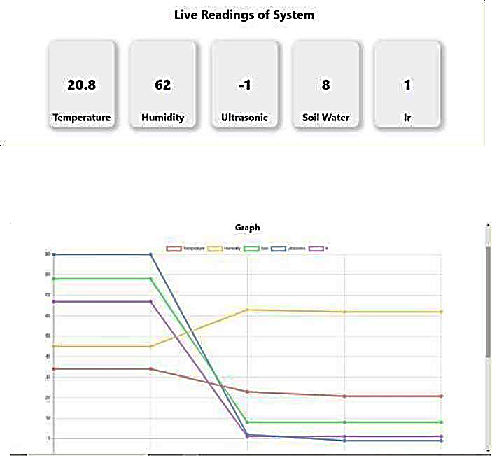3. System not only reduces the wastage of water resources but also saves time and human effort.

**Figure 4.1 Readings**

**CHAPTER 5**

**5.1 Conclusion**

This project was to design a system for monitoring various factors that impact plant growth, such as temperature, humidity, and moisture levels in the soil. The project also aimed to analyze existing systems and identify their strengths and weaknesses. One potential application of the proposed system is in agriculture, where irrigation is a critical but water-intensive process. By using sensor data to automatically turn the irrigation motor on or off, the system can help farmers optimize their use of water and avoid over or under-irrigation, which can damage crops. The farm owner can monitor the system remotely using a front-end interface. By conserving water and reducing the power consumption of the irrigation motor, the system can help to sustainably support the growth of crops. Overall, the project highlights the potential of IOT and automation to improve farming practices.

**5.2 Future Scope**

1. Enhance the security of both the device and the owner's account.

2. Incorporate a sensor for detecting the amount of sunlight available to the plant.

3. Utilize artificial intelligence to assess the health of the plant.

4. Reduce the size of the system and make it more versatile for different installations.

5. Design the system to be powered by a solar cell, eliminating the need for an electrical plug.

**CHAPTER 6**

**References**

**[1] International Journal of Engineering Research and Technology**

Prof. Kawale Jayashri , Sanjay More, Akshay Bankar, Ganesh Dongre, Pooja Patil, “I0T BASED SMART PLANT MONITORING SYSTEM”, International Journal of Advance Research in Science and Engineering, Vol. No. 7.

**[2] Journal of emerging technologies and innovative research**

Yogendra Parihar, “Internet of Things and Node MCU”, JETIR, Vol. No. 6.

**[3] International Journal of Engineering Research and Technology**

Gabriel, “Monitoring Moisture and Humidity using Arduino Nano”, IJERT, Vol. No.

**[4] Internet of Medical Things (IOMT): Applications, Benefits and Future Challenges in Healthcare Domain**

oyia G.J., Liaqat R.M., Farooq A., Rehman S. Internet of Medical Things (IOMT): applications, benefits and future challenges in healthcare domain.

**[5] IOP Confrence Series: Material Science and Engineering**

Ultrasonic sensor for monitoring corn growth based on Raspberry Pi by A Latifah, WRamdhani, M R Nasrulloh and R Elsen. A Latifah et al 2021 IOP Conf. Ser.: Mater. Sci. Eng. 1098 042087.

**[6] National Library of Medicine**

Object Detection for Agricultural and Construction Environments Using an Ultrasonic Sensor by J.S. Dvorak, M.L. Stone, K.P. Self.

**[7] Federal Ministry of Food and Education**

Water and Agriculture in India Background paper for the South Asia expert panel during the Global Forum for Food and Agriculture (GFFA) 2017 by Dr. Vibha Dhawan.

**[8] Science Direct**

Current understanding, challenges and perspective on portable systems applied to plant monitoring and precision agriculture.

**Annexure A**

**Outcome**

It aims to enhance the efficiency and sustainability of agriculture through the utilization of Internet of Things (IoT) technology. The project introduces a plant monitoring system that collects data on key parameters such as temperature, humidity, and moisture levels in the field area. The system incorporates Node MCU and various sensors, including temperature, moisture, and humidity sensors, to gather comprehensive data on different aspects of plant growth.

The collected data plays a crucial role in providing valuable insights into the health of the plants and optimizing their growth and development. By leveraging the IoT framework, the project is designed to be scalable and adaptable to various types of plants and environments. Additionally, the system can be integrated with other IoT-enabled devices, forming a comprehensive monitoring and control system for agriculture.

One of the significant features of the Smart Bio Monitoring System is its ability to detect and alert users to potential issues, such as over-watering or exposure to extreme temperatures. These alerts ensure prompt intervention and enable users to take necessary actions to maintain the optimal conditions for plant growth. The system's innovative approach offers benefits to farmers, gardeners, and individuals with plants in hard-to-reach or inaccessible locations. Furthermore, it provides support for those new to gardening or seeking to optimize their cultivation efforts.

The project's technological components include the Internet of Things (IoT) framework, Arduino-based Node MCU, and various sensors such as temperature sensors, humidity sensors, soil moisture sensors, ultrasonic sensors, water pumps, and relays. These elements work together to monitor and control the environment for plants.

The Smart Bio Monitoring System demonstrates the potential for significant contributions to the field of IoT-based agriculture by improving the way plants are grown and maintained. By leveraging real-time data, remote monitoring, and automated control, this system offers an innovative solution for plant monitoring and maintenance.

**Conference Details**

**Title of Paper :-** Smart Bio Monitoring System

**Name of Scopus Conference/Journal :-** EPRA International Journal of Agriculture and Rural Economic Research (ARER)-ISSN

**Date of submission :-** 07 /05/2023

**Date of acceptance :-** 09/05/2023

**Date of publication :- NA**

**Proof of Submission:-**





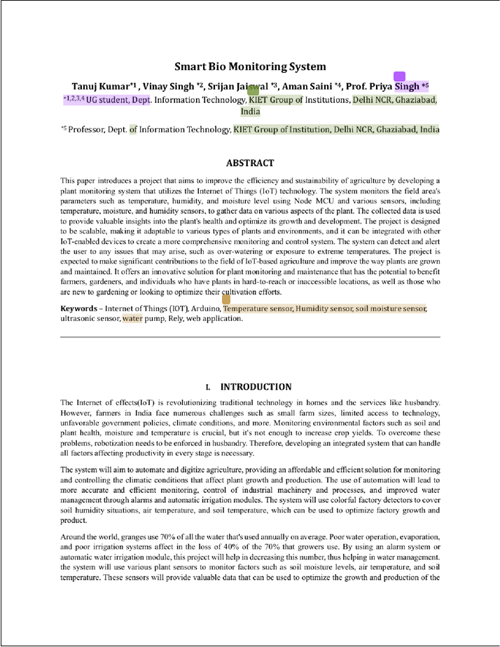

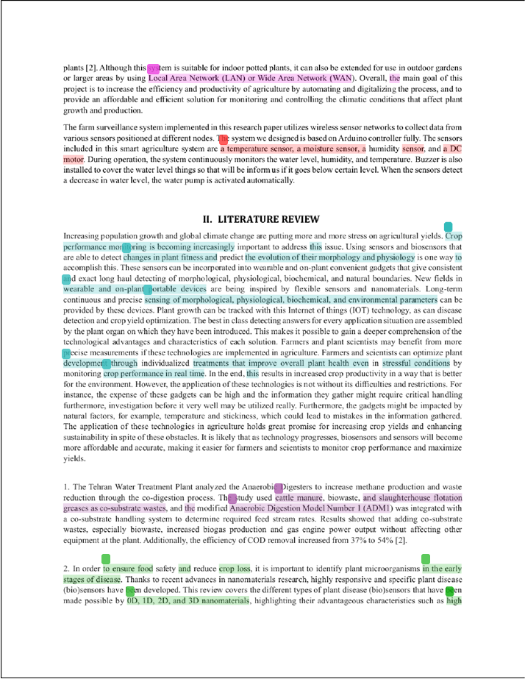

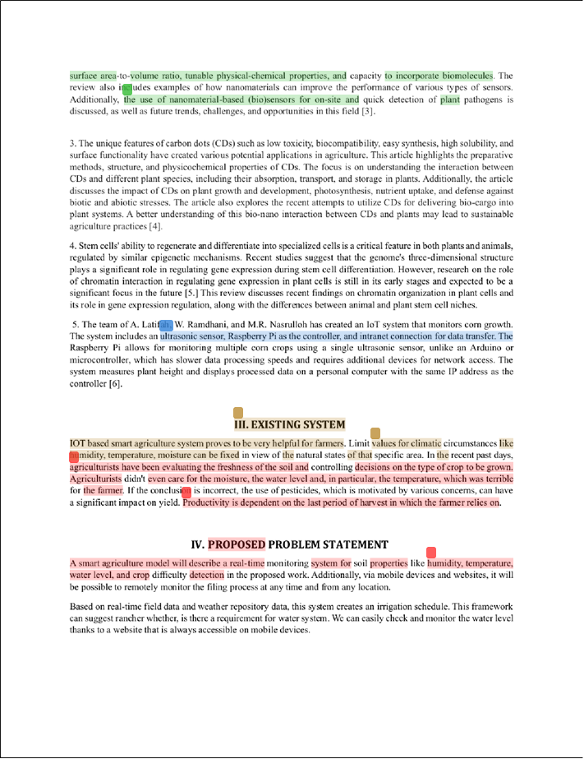

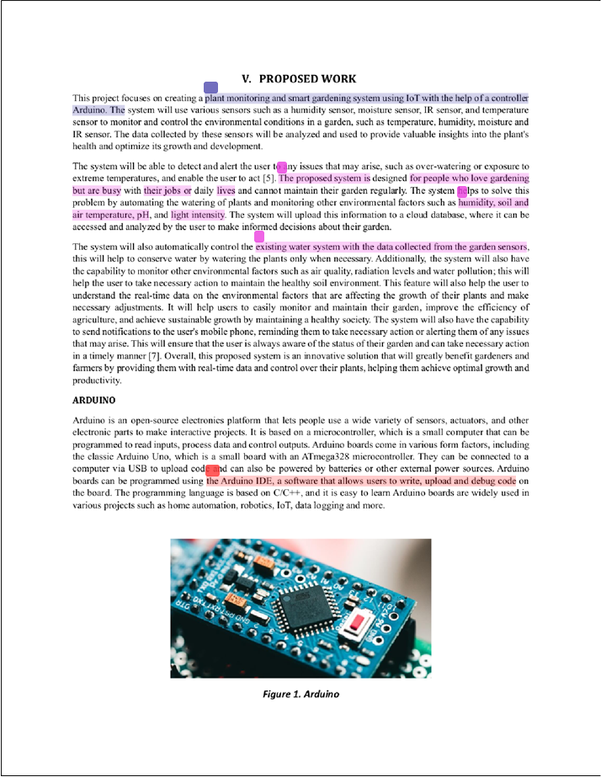

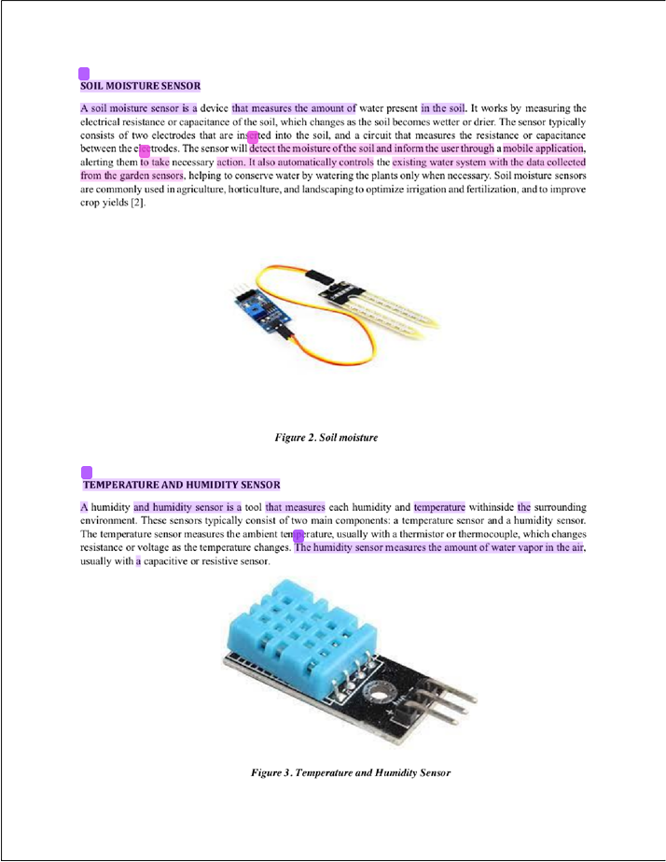

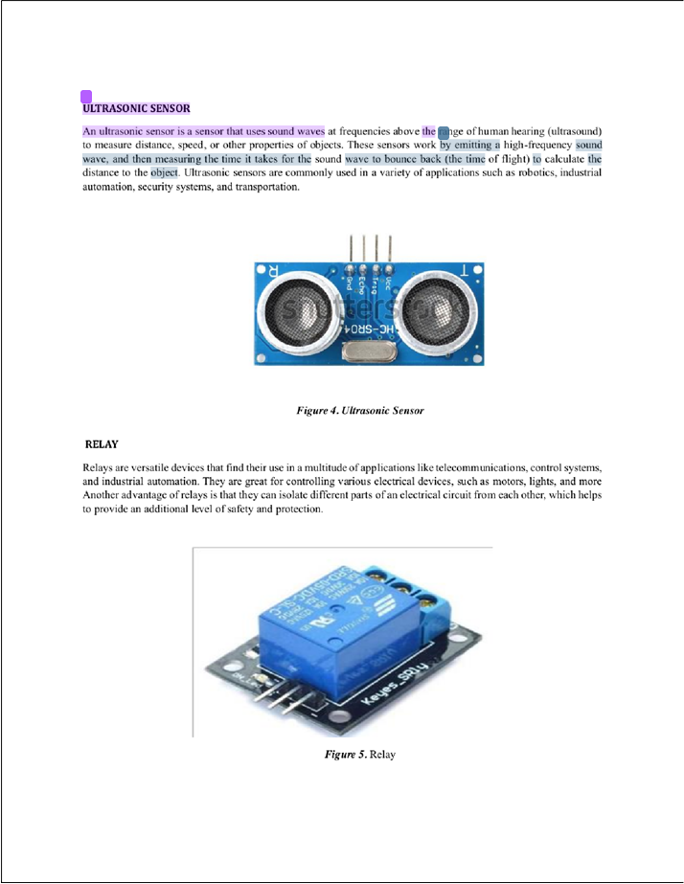



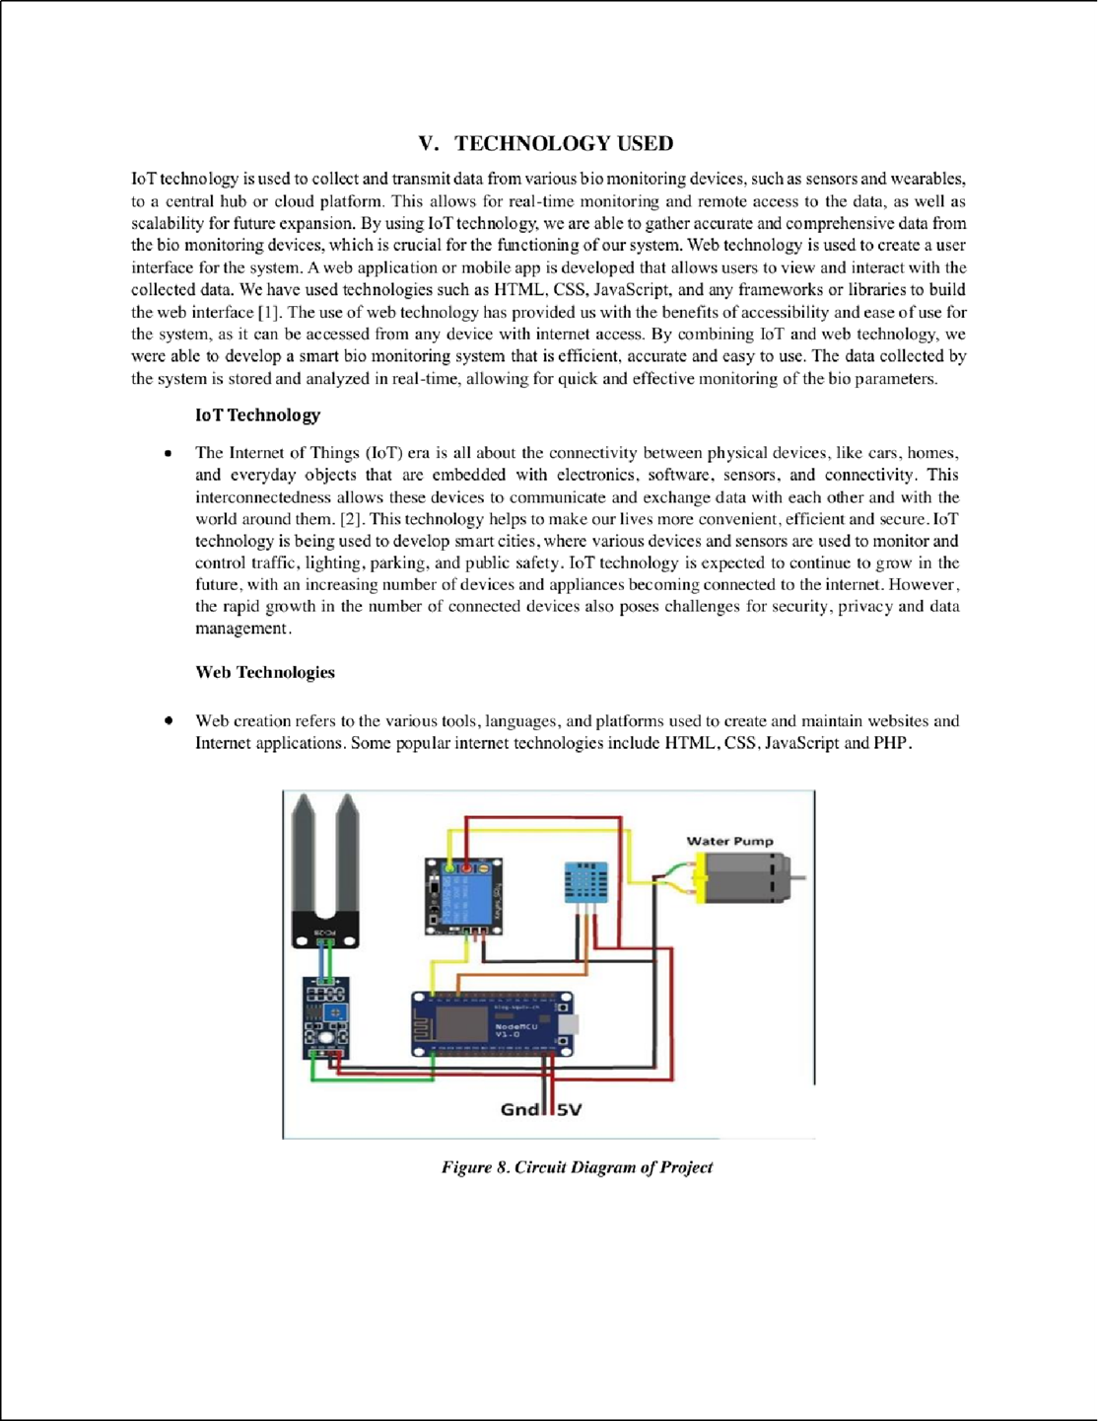

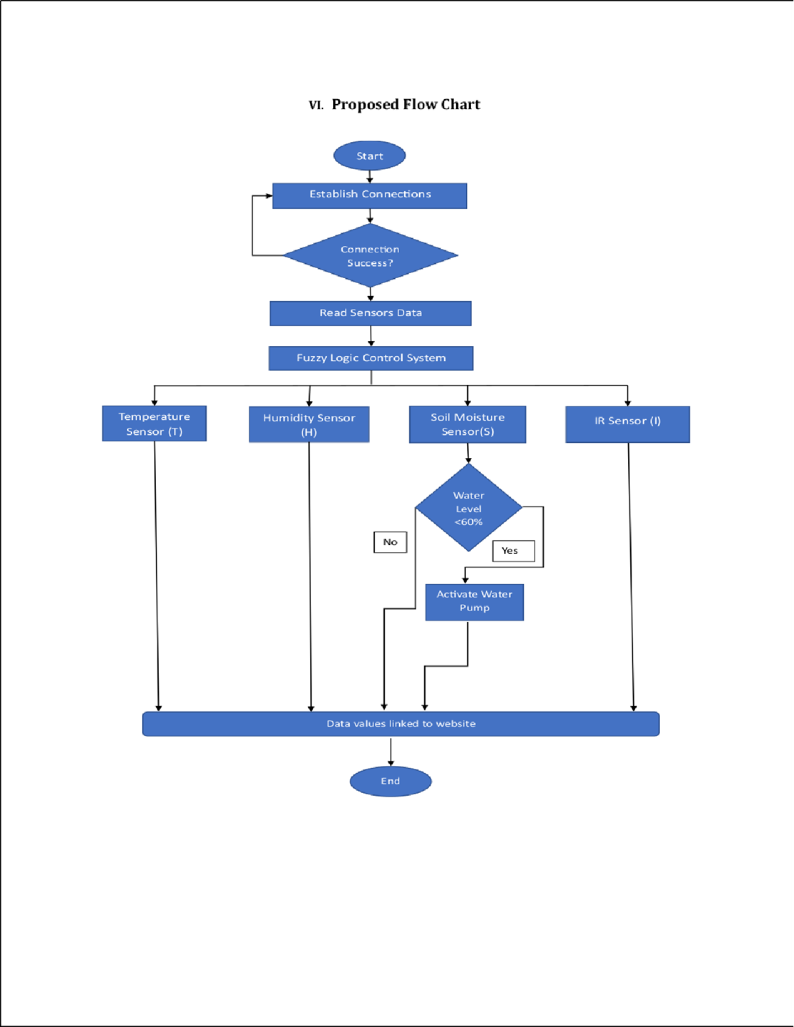

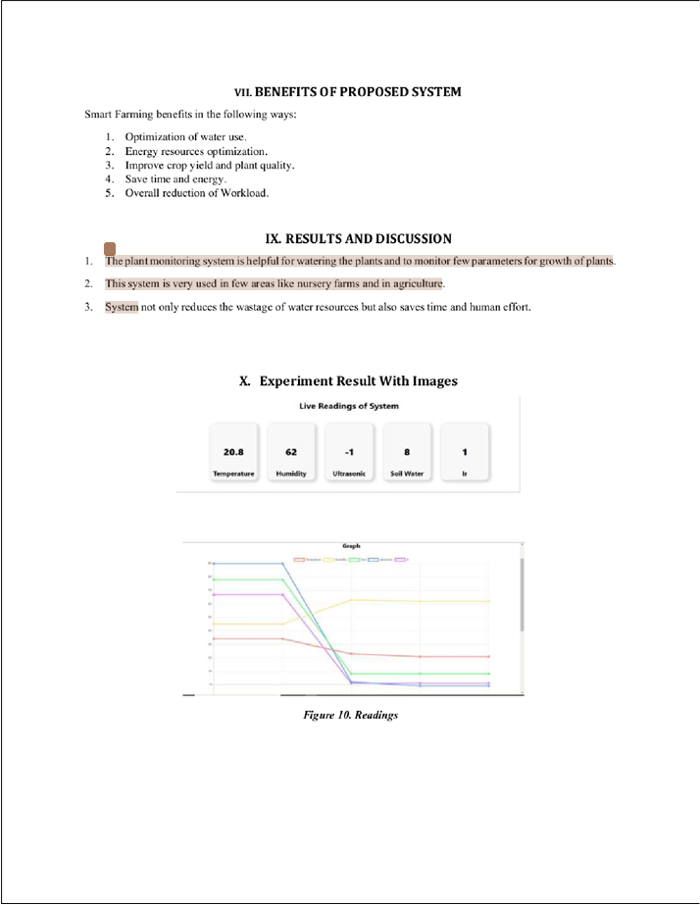

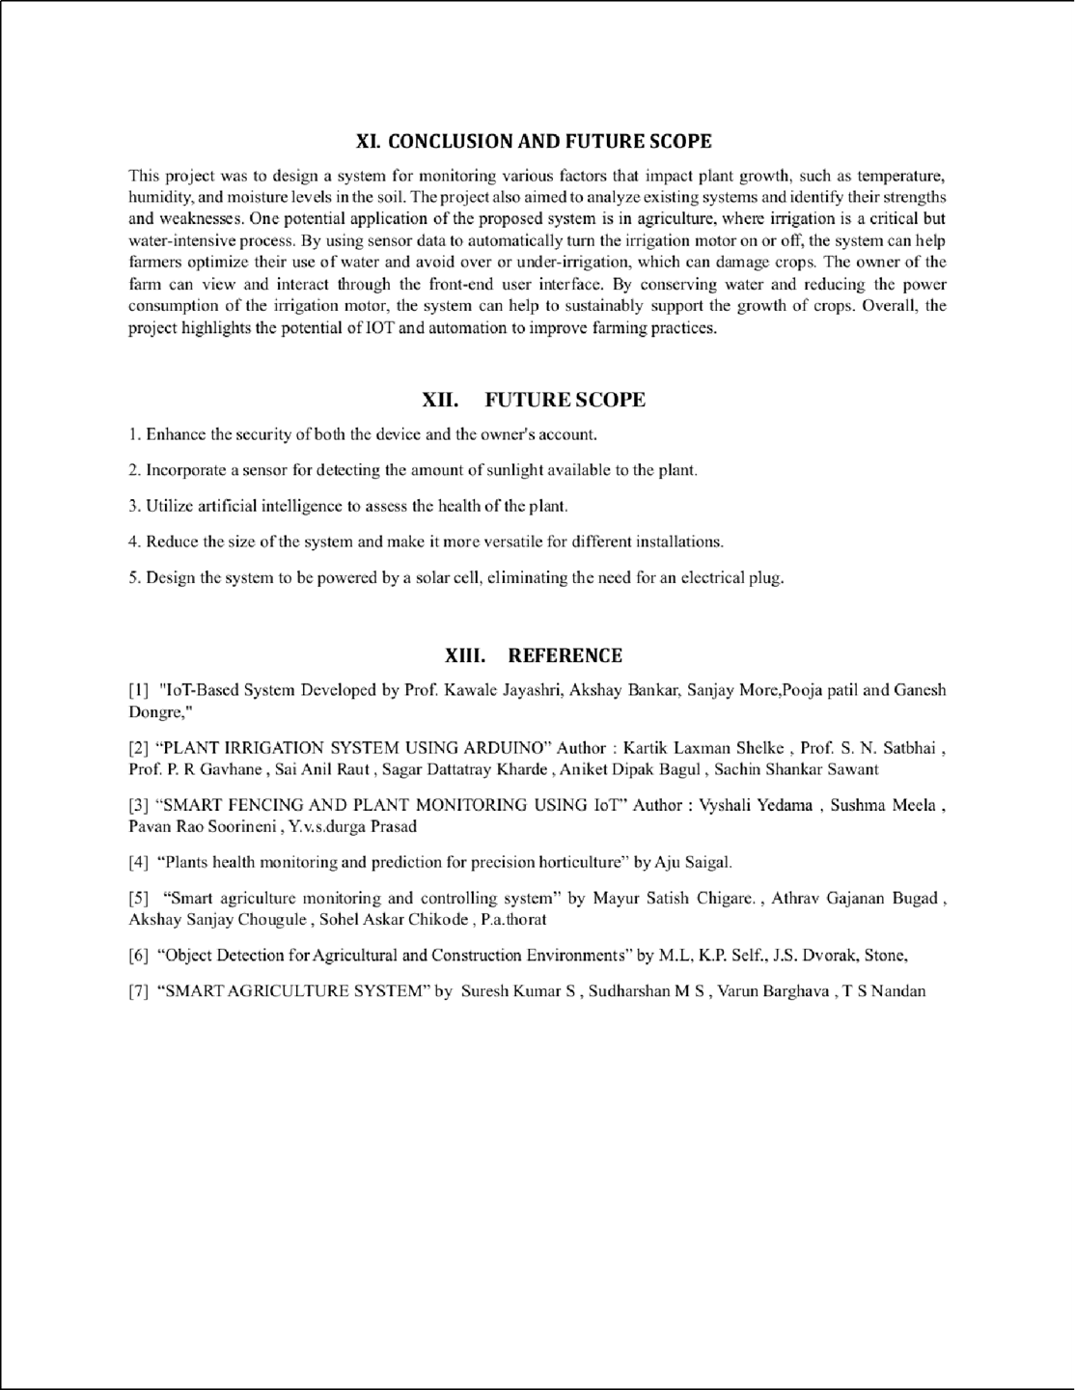



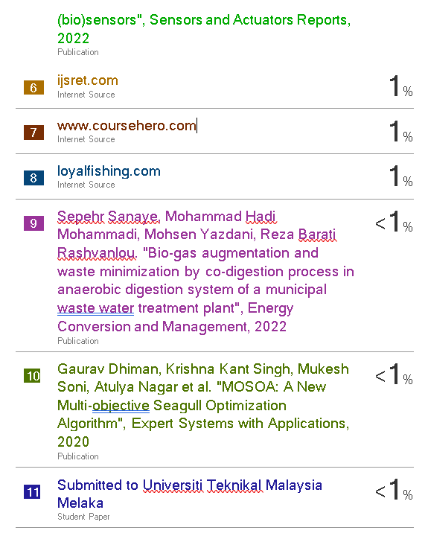

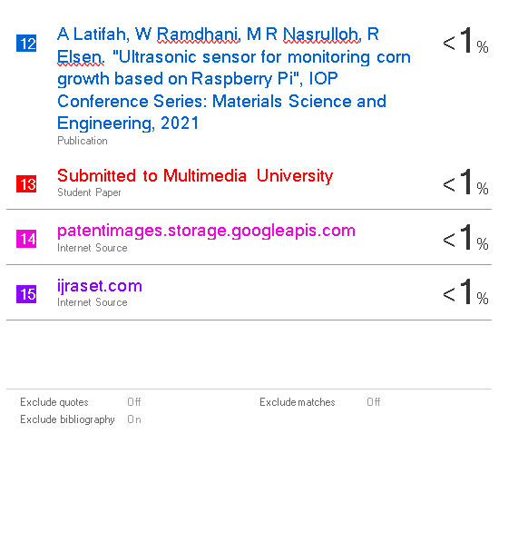

**Annexure 2**

**Final Submitted paper**

